AI POWERED PREDICTION OF STRESS LEVEL WITH THE CO ORDINATION OF HEART AND BRAIN USING MACHINE LEARNING

TABLE OF CONTENT

SL.NO | TITLE | PAGE.NO
01 | ABSTRACT
02 | EXISTING SYSTEM  2.1 DRAWBACKS
03 | INTRODUCTION  3.1 DATA SCIENCE  3.2 ARTIFICIAL INTELLIGENCE
04 | MACHINE LEARNING
05 | PREPARING DATASET
06 | PROPOSED SYSTEM  6.1 ADVANTAGES
07 | LITERATURE SURVEY
08 | SYSTEM STUDY  8.1 OBJECTIVES  8.2 PROJECT GOAL  8.3 SCOPE OF THE PROJECT
09 | FEASIBILITY STUDY
10 | LIST OF MODULES
11 | PROJECT REQUIREMENTS  11.1 FUNCTIONAL REQUIREMENTS  11.2 NON-FUNCTIONAL REQUIREMENTS
12 | ENVIRONMENT REQUIREMENT
13 | SOFTWARE DESCRIPTION  13.1 ANACONDA NAVIGATOR  13.2 JUPYTER NOTEBOOK
14 | PYTHON
15 | SYSTEM ARCHITECTURE
16 | WORKFLOW DIAGRAM
17 | USECASE DIAGRAM
18 | CLASS DIAGRAM
19 | ACTIVITY DIAGRAM
20 | SEQUENCE DIAGRAM
21 | ER – DIAGRAM
22 | MODULE DESCRIPTION  22.1 MODULE DIAGRAM  22.2 MODULE GIVEN INPUT EXPECTED OUTPUT
23 | DEPLOYMENT
24 | HTML
25 | CSS
26 | CODING
27 | CONCLUSION
28 | FUTURE WORK

LIST OF FIGURES

SL.NO | TITLE | PAGE.NO
01 | SYSTEM ARCHITECTURE
02 | WORKFLOW DIAGRAM
03 | USECASE DIAGRAM
04 | CLASS DIAGRAM
05 | ACTIVITY DIAGRAM
06 | SEQUENCE DIAGRAM
07 | ER – DIAGRAM
08 | MODULE DIAGRAM

LIST OF SYMBOLS

S.NO | NOTATION  NAME | NOTATION | DESCRIPTION
1. | Class | Class Name  -attribute  -attribute  +operation  +operation  +operation  + public  -private  # protected | Represents a collection of similar entities grouped together.
2. | Association | nAME  Class A  Class B  Class A  Class B | Associations represents static relationships between classes. Roles representsthe way the two classes see each other.
3. | Actor | Class A  Class A  Class B  Class B | It aggregates several classes into a single classes.
4. | Aggregation | Class A  Class A  Class B  Class B | Interaction between the system and external environment

5. | Relation  (uses) | uses | Used for additional process communication.
6. | Relation  (extends) | EXTENDS | Extends relationship is used when one use case is similar to another use case but does a bit more.
7. | Communication |  | Communication between various use cases.
8. | State | State | State of the processs.
9. | Initial State |  | Initial state of the object
10. | Final state |  | Final state of the object
11. | Control flow |  | Represents various control flow between the states.
12. | Decision box |  | Represents decision making process from a constraint
13. | Usecase | Usescase | Interact ion between the system and external environment.

14. | Component |  | Represents physical modules which is a collection of components.
15. | Node |  | Represents physical modules which are a collection of components.
16. | Data Process/State |  | A circle in DFD represents a state or process which has been triggered due to some event or acion.
17. | External entity |  | Represents external entities such as keyboard,sensors,etc.
18. | Transition |  | Represents communication that occurs between processes.
19. | Object Lifeline |  | Represents the vertical dimensions that the object communications.
20. | Message | Message | Represents the message exchanged.

ABSTRACT:
NeurocardioSync is a cutting-edge software system that leverages machine learning algorithms to predict an individual’s stress levels by analyzing physiological and neurological parameters related to the heart and brain. Human daily activities and lifestyle habits can gradually disrupt the natural coordination between the cardiovascular and nervous systems, leading to chronic stress and associated health issues. Conventional health checkups often fail to detect these subtle changes early due to their infrequent nature. NeurocardioSync continuously monitors relevant heart and brain signals, processes them using advanced machine learning models, and provides accurate stress predictions. This proactive approach enables early detection and personalized interventions to maintain mental and physical well-being. The system integrates data-driven insights, real-time analysis, and predictive intelligence to offer a comprehensive understanding of brain-heart interactions under various conditions.

Keywords: Stress prediction, Brain-heart coordination, Machine learning, Physiological monitoring, Neural signals, Cardiovascular signals, Neurocardiac health, Chronic stress detection, Health analytics.

EXISTING SYSTEM:
Recent advancements in the manufacturing and commercialisation of miniaturised sensors and low-cost wearables have enabled an effortless monitoring of lifestyle by detecting and analysing physiological signals. Heart rate variability (HRV) denotes the time interval between consecutive heartbeats. The HRV signal, as detected by the sensors and devices, has been popularly used as an indicative measure to estimate the level of stress, depression, and anxiety. For years, artificial intelligence (AI)-based learning systems have been known for their predictive capabilities, and in recent years, AI models with deep learning (DL) architectures have been successfully applied to achieve unprecedented accuracy. In order to deter mine effective methodologies applied to the collection, processing, and prediction of stress from HRV data, this work presents an in depth analysis of 43 studies reporting the application of various AI algorithms. The methods are summarised in tables and thoroughly evaluated to ensure the completeness of their findings and reported results. To make the work comprehensive, a detailed review has been conducted on sensing technologies, pre-processing methods applied on multi-modal data, and employed prediction models. This is followed by a critical examination of how various Machine Learning (ML) models, have been utilised in predicting stress from HRV data. In addition, the reported reseults from the selected studies have been carefully analysed to identify features that enable the models to perform better. Finally, the challenges of using HRV to predict stress are listed, along with some possible mitigation strategies. This work aims to highlight the impact of AI-based stress prediction methodologies from HRV data, and is expected to aid the development of more meticulous techniques.

DEMERITS:
- Miniaturized wearable sensors may suffer from noise, signal drift, or poor placement, which can affect the accuracy of HRV measurements and, consequently, stress predictions.
- Most systems rely heavily on HRV alone, without fully integrating other physiological signals (EEG, GSR, respiratory rate), which may limit the prediction accuracy for complex stress scenarios.
- HRV patterns can vary significantly between individuals due to age, gender, fitness level, or pre-existing health conditions, making it challenging for AI models to generalize across diverse populations.
- HRV data alone cannot account for psychological or environmental factors influencing stress (e.g., workload, lifestyle, emotional state), which may lead to false positives or negatives.
- Preprocessing HRV signals for noise reduction, artifact removal, and feature extraction can be computationally intensive and prone to errors, impacting the performance of AI models.
- Many AI/DL models require large, labeled datasets for training. Limited availability of high-quality HRV datasets can restrict model effectiveness, especially for personalized stress prediction.

3. INTRODUCTION
In today’s fast-paced and digitally driven world, stress has become a common and serious health concern affecting individuals across all age groups. Prolonged exposure to stress can disrupt the natural coordination between the brain and the heart, leading to long-term physical and psychological disorders such as anxiety, depression, hypertension, and cardiovascular diseases. Traditionally, stress assessment relies on self-reported questionnaires or occasional medical checkups, which often fail to capture gradual physiological changes occurring during daily life.
Recent advancements in wearable sensor technology and machine learning have enabled continuous monitoring of physiological signals such as Heart Rate Variability (HRV) and brain electrical activity. While existing systems predominantly focus on HRV-based stress estimation, they often overlook the vital role of brain-heart coordination in accurately identifying stress levels. To overcome these limitations, NeurocardiaSync introduces an AI-powered approach that integrates heart and brain related parameters to deliver more reliable and personalized stress predictions. By leveraging machine learning techniques, the system aims to detect stress early and support preventive healthcare through real-time monitoring and intelligent analysis.

3.1 Data Science
Data science is an interdisciplinary field that uses scientific methods, processes, algorithms and systems to extract knowledge and insights from structured and unstructured data, and apply knowledge and actionable insights from data across a broad range of application domains.
The term "data science" has been traced back to 1974, when Peter Naur proposed it as an alternative name for computer science. In 1996, the International Federation of Classification Societies became the first conference to specifically feature data science as a topic. However, the definition was still in flux.
The term “data science” was first coined in 2008 by D.J. Patil, and Jeff Hammerbacher, the pioneer leads of data and analytics efforts at LinkedIn and Facebook. In less than a decade, it has become one of the hottest and most trending professions in the market.
Data science is the field of study that combines domain expertise, programming skills, and knowledge of mathematics and statistics to extract meaningful insights from data.
Data science can be defined as a blend of mathematics, business acumen, tools, algorithms and machine learning techniques, all of which help us in finding out the hidden insights or patterns from raw data which can be of major use in the formation of big business decisions.

Data Scientist:
Data scientists examine which questions need answering and where to find the related data. They have business acumen and analytical skills as well as the ability to mine, clean, and present data. Businesses use data scientists to source, manage, and analyze large amounts of unstructured data.
Required Skills for a Data Scientist:
- Programming: Python, SQL, Scala, Java, R, MATLAB.
- Machine Learning: Natural Language Processing, Classification, Clustering.
- Data Visualization: Tableau, SAS, D3.js, Python, Java, R libraries.
- Big data platforms: MongoDB, Oracle, Microsoft Azure, Cloudera.

3.2 ARTIFICIAL INTELLIGENCE
Artificial intelligence (AI) refers to the simulation of human intelligence in machines that are programmed to think like humans and mimic their actions. The term may also be applied to any machine that exhibits traits associated with a human mind such as learning and problem-solving.
Artificial intelligence (AI) is intelligence demonstrated by machines, as opposed to the natural intelligence displayed by humans or animals. Leading AI textbooks define the field as the study of "intelligent agents" any system that perceives its environment and takes actions that maximize its chance of achieving its goals. Some popular accounts use the term "artificial intelligence" to describe machines that mimic "cognitive" functions that humans associate with the human mind, such as "learning" and "problem solving", however this definition is rejected by major AI researchers.
Artificial intelligence is the simulation of human intelligence processes by machines, especially computer systems. Specific applications of AI include expert systems, natural language processing, and speech recognition and machine vision.
AI applications include advanced web search engines, recommendation systems (used by Youtube, Amazon and Netflix), Understanding human speech (such as Siri or Alexa), self-driving cars (e.g. Tesla), and competing at the highest level in strategic game systems (such as chess and Go), As machines become increasingly capable, tasks considered to require "intelligence" are often removed from the definition of AI, a phenomenon known as the AI effect. For instance, optical character recognition is frequently excluded from things considered to be AI, having become a routine technology.
Artificial intelligence was founded as an academic discipline in 1956, and in the years since has experienced several waves of optimism, followed by disappointment and the loss of funding (known as an "AI winter"), followed by new approaches, success and renewed funding. AI research has tried and discarded many different approaches during its lifetime, including simulating the brain, modeling human problem solving, formal logic, large databases of knowledge and imitating animal behavior. In the first decades of the 21st century, highly mathematical statistical machine learning has dominated the field, and this technique has proved highly successful, helping to solve many challenging problems throughout industry and academia.
The various sub-fields of AI research are centered on particular goals and the use of particular tools. The traditional goals of AI research include reasoning, knowledge representation, planning, learning, natural language processing, perception and the ability to move and manipulate objects. General intelligence (the ability to solve an arbitrary problem) is among the field's long-term goals. To solve these problems, AI researchers use versions of search and mathematical optimization, formal logic, artificial neural networks, and methods based on statistics, probability and economics. AI also draws upon computer science, psychology, linguistics, philosophy, and many other fields.
The field was founded on the assumption that human intelligence "can be so precisely described that a machine can be made to simulate it". This raises philosophical arguments about the mind and the ethics of creating artificial beings endowed with human-like intelligence. These issues have been explored by myth, fiction and philosophy since antiquity. Science fiction and futurology have also suggested that, with its enormous potential and power, AI may become an existential risk to humanity.
As the hype around AI has accelerated, vendors have been scrambling to promote how their products and services use AI. Often what they refer to as AI is simply one component of AI, such as machine learning. AI requires a foundation of specialized hardware and software for writing and training machine learning algorithms. No one programming language is synonymous with AI, but a few, including Python, R and Java, are popular.
In general, AI systems work by ingesting large amounts of labeled training data, analyzing the data for correlations and patterns, and using these patterns to make predictions about future states. In this way, a chatbot that is fed examples of text chats can learn to produce life like exchanges with people, or an image recognition tool can learn to identify and describe objects in images by reviewing millions of examples.
AI programming focuses on three cognitive skills: learning, reasoning and self-correction.
Learning processes. This aspect of AI programming focuses on acquiring data and creating rules for how to turn the data into actionable information. The rules, which are called algorithms, provide computing devices with step-by-step instructions for how to complete a specific task.
Reasoning processes. This aspect of AI programming focuses on choosing the right algorithm to reach a desired outcome.
Self-correction processes. This aspect of AI programming is designed to continually fine-tune algorithms and ensure they provide the most accurate results possible.
AI is important because it can give enterprises insights into their operations that they may not have been aware of previously and because, in some cases, AI can perform tasks better than humans. Particularly when it comes to repetitive, detail-oriented tasks like analyzing large numbers of legal documents to ensure relevant fields are filled in properly, AI tools often complete jobs quickly and with relatively few errors.
Artificial neural networks and deep learning artificial intelligence technologies are quickly evolving, primarily because AI processes large amounts of data much faster and makes predictions more accurately than humanly possible.
Natural Language Processing (NLP):
Natural language processing (NLP) allows machines to read and understand human language. A sufficiently powerful natural language processing system would enable natural-language user interfaces and the acquisition of knowledge directly from human-written sources, such as newswire texts. Some straightforward applications of natural language processing include information retrieval, text mining, question answering and machine translation. Many current approaches use word co-occurrence frequencies to construct syntactic representations of text. "Keyword spotting" strategies for search are popular and scalable but dumb; a search query for "dog" might only match documents with the literal word "dog" and miss a document with the word "poodle". "Lexical affinity" strategies use the occurrence of words such as "accident" to assess the sentiment of a document. Modern statistical NLP approaches can combine all these strategies as well as others, and often achieve acceptable accuracy at the page or paragraph level. Beyond semantic NLP, the ultimate goal of "narrative" NLP is to embody a full understanding of common sense reasoning. By 2019, transformer-based deep learning architectures could generate coherent text.

4. MACHINE LEARNING:

Machine learning is to predict the future from past data. Machine learning (ML) is a type of artificial intelligence (AI) that provides computers with the ability to learn without being explicitly programmed. Machine learning focuses on the development of Computer Programs that can change when exposed to new data and the basics of Machine Learning, implementation of a simple machine learning algorithm using python. Process of training and prediction involves use of specialized algorithms. It feed the training data to an algorithm, and the algorithm uses this training data to give predictions on a new test data. Machine learning can be roughly separated in to three categories. There are supervised learning, unsupervised learning and reinforcement learning. Supervised learning program is both given the input data and the corresponding labelling to learn data has to be labelled by a human being beforehand. Unsupervised learning is no labels. It provided to the learning algorithm. This algorithm has to figure out the clustering of the input data. Finally, Reinforcement learning dynamically interacts with its environment and it receives positive or negative feedback to improve its performance.
Data scientists use many different kinds of machine learning algorithms to discover patterns in python that lead to actionable insights. At a high level, these different algorithms can be classified into two groups based on the way they “learn” about data to make predictions: supervised and unsupervised learning. Classification is the process of predicting the class of given data points. Classes are sometimes called as targets/ labels or categories. Classification predictive modeling is the task of approximating a mapping function from input variables(X) to discrete output variables(y). In machine learning and statistics, classification is a supervised learning approach in which the computer program learns from the data input given to it and then uses this learning to classify new observation. This data set may simply be bi-class (like identifying whether the person is male or female or that the mail is spam or non-spam) or it may be multi-class too. Some examples of classification problems are: speech recognition, handwriting recognition, bio metric identification, document classification etc.

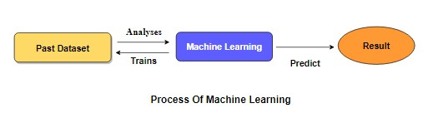
Supervised Machine Learning is the majority of practical machine learning uses supervised learning. Supervised learning is where have input variables (X) and an output variable (y) and use an algorithm to learn the mapping function from the input to the output is y = f(X). The goal is to approximate the mapping function so well that when you have new input data (X) that you can predict the output variables (y) for that data. Techniques of Supervised Machine Learning algorithms include logistic regression, multi-class classification, Decision Trees and support vector machines etc. Supervised learning requires that the data used to train the algorithm is already labelled with correct answers. Supervised learning problems can be further grouped into Classification problems. This problem has as goal the construction of a succinct model that can predict the value of the dependent attribute from the attribute variables. The difference between the two tasks is the fact that the dependent attribute is numerical for categorical for classification. A classification model attempts to draw some conclusion from observed values. Given one or more inputs a classification model will try to predict the value of one or more outcomes. A classification problem is when the output variable is a category, such as “red” or “blue”.

5. Preparing the Dataset:
This dataset contains number of records of features extracted from patients, which were then used to find the heart attack from the patient.

6. PROPOSED SYSTEM:
The proposed system NeurocardiaSync is an AI powered stress prediction framework that continuously analyzes heart and brain related physiological data to assess an individual’s stress level in real time. The system integrates multi modal sensor data, including Heart Rate Variability (HRV) derived from ECG/PPG signals and brain electrical activity (EEG), to capture subtle changes in autonomic and cognitive responses caused by stress. Initial data acquisition collects real time signals during typical daily activities using wearable sensors. Next, advanced signal processing methods extract meaningful features such as HRV metrics and EEG band power indicators. These features are then fed into machine learning models (e.g., ensemble classifiers or deep learning architectures) trained to distinguish between stress levels (low/medium/high). By correlating cardiac dynamics with neural signatures, NeurocardiaSync offers a robust and personalized stress estimation tool that highlights deviations from normal brain heart coordination. The system also provides visual dashboards and alerts to guide users toward timely interventions and lifestyle modifications, thereby promoting better mental and physical health outcomes.
MERITS:
- Early Stress Detection: Identifies stress before it manifests as physical or mental health issues.
- Continuous Monitoring: Tracks heart and brain coordination in real-time, unlike periodic health checkups.
- Personalized Insights: Offers individualized recommendations based on unique physiological patterns.
- Data-Driven Approach: Leverages machine learning for accurate and reliable stress prediction.
- Preventive Healthcare: Supports proactive management of chronic stress and related health risks.
- Non-Invasive: Uses wearable sensors and software-based analysis, ensuring user comfort.

Heart And Brain Dataset
Data Processing
Test dataset
Neuro-cardio stress level Prediction
Training dataset
Classification ML Algorithm

Architecture of Proposed model

7. Literature survey:
General
A literature review is a body of text that aims to review the critical points of current knowledge on and/or methodological approaches to a particular topic. It is secondary sources and discuss published information in a particular subject area and sometimes information in a particular subject area within a certain time period. Its ultimate goal is to bring the reader up to date with current literature on a topic and forms the basis for another goal, such as future research that may be needed in the area and precedes a research proposal and may be just a simple summary of sources. Usually, it has an organizational pattern and combines both summary and synthesis.
A summary is a recap of important information about the source, but a synthesis is a re-organization, reshuffling of information. It might give a new interpretation of old material or combine new with old interpretations or it might trace the intellectual progression of the field, including major debates. Depending on the situation, the literature review may evaluate the sources and advise the reader on the most pertinent or relevant of them.
Review of Literature Survey:
Title : AI-Driven Stress Monitoring for Older Adults: A Wearable IOT Solution.
Author: Komal Mishra , Gaurav Bhushan, Amit Kumar Ahuja.
Year : 2021
Stress is a state of increased physical and psychological tension that can significantly affect an individual’s health and well-being. Various physiological, psychological, environmental, and emotional factors contribute to stress, and poor management can lead to serious health consequences. If not addressed well on time, stress may lead to different neurological disorders which can be detrimental to human health. This paper reviews existing research on stress detection and reduction, examining different methodologies and technologies in the field. Despite advances in stress monitoring solutions, most studies focus on younger populations, workplace settings, or general healthcare, with limited attention to elderly individuals in residential care. To address this gap, this paper proposes an IoT (Internet of Things)-enabled wearable wristband designed for the unique needs of elderly residents in care facilities. The device integrates multiple physiological sensors, including Galvanic Skin Response (GSR), skin temperature, Heart Rate Variability (HRV), accelerometer, and gyroscopic sensors, for real-time stress detection using an adaptive fuzzy logic algorithm. Unlike conventional methods, this system offers personalized interventions such as guided relaxation, breathing exercises, music therapy, and light physical activities, tailored to the user’s real-time physiological state.

Title : Mental Stress Detection In Real Time Using Wearable Sensors And Machine Learning.
Author: MUVVA VENKATESWARA RAO , GORU SONIYA
Year : 2023
When we encounter difficult or taxing circumstances, or stressors, our bodies and minds go into a hyperarousal state, commonly known as stress. Chronic illnesses including anxiety, depression, and cardiovascular disease can develop in people who are exposed to various stressors for an extended period of time, particularly when these stressors happen at the same time. In order to avoid these long-term impacts, it is essential to recognise stress early on, and continuous monitoring provides a viable option. One possibility for personal stress monitoring is the use of wearable devices that can gather data continuously and in real-time, allowing users to keep tabs on their stress levels as the day progresses. This study provides an extensive analysis of several approaches to stress detection that make use of wearable sensors in conjunction with machine learning methodologies. Wearable sensors including electrocardiograms (ECGs), electroencephalograms (EEGs), and photoplethysmography (PPGs) are reviewed, along with the many settings when stress is tracked, such as while driving, learning, or working.

Title : AI-Driven Mental Health Monitoring System: A Predictive Framework for Anxiety, Depression, and Stress Management.
Author: Ayushi Saini , Mansi Yadav , Ravi Singh
Year : 2023
Mental health is an integral com- ponent of overall well-being, affecting cognitive, emotional, and social aspects of life. In recent years, conditions such as anxiety, depression, and stress have emerged as significant public health concerns, impacting millions of individuals globally. However, addressing these issues is often hindered by social stigma, lack of access to timely mental health resources, and the subjective nature of traditional diagnostic methods. This research introduces an innovative AI-driven mental health monitoring system aimed at bridging these gaps. The system leverages advanced machine learning algorithms to analyze multimodal data, including physiological metrics (e.g., heart rate, sleep patterns, and activity levels), social interactions (e.g., social media activity and engagement), and sentiment analysis derived from textual content. Feature engineering plays a critical role in this approach by extracting meaningful patterns from raw data, such as Mood-Stress Ratios, Routine Disruption Scores, and Social Engagement Scores. By integrating diverse data sources and employing both regression and classification models, the system achieves high accuracy in predicting mental health conditions like anxiety scores, depression levels, and high-stress indicators. This proactive monitoring enables individuals to identify potential mental health issues early and seek appropriate interventions.

Title : Cardiac Disease Prediction using Supervised Machine Learning Techniques.
Author: Chiradeep Gupta1,4, Athina Saha
Year : 2022
Diagnosis of cardiac disease requires being more accurate, precise, and reliable. The number of death cases due to cardiac attacks is increasing exponentially day by day. Thus, practical approaches for earlier diagnosis of cardiac or heart disease are done to achieve prompt management of the disease. Various supervised machine-learning techniques like K-Nearest Neighbour, Decision Tree, Logistic Regression, Naïve Bayes, and Support Vector Machine (SVM) model are used for predicting cardiac disease using a dataset that was collected from the repository of the University of California, Irvine (UCI). The results depict that Logistic Regression was better than all other supervised classifiers in terms of the performance metrics. The model is also less risky since the number of false negatives is low as compared to other models as per the confusion matrix of all the models. In addition, ensemble techniques can be approached for the accuracy improvement of the classifier. Jupyter notebook is the best tool, for the implementation of Python Programming having many types of libraries, header files, for accurate and precise work

Title : State-of-the-Art of Stress Prediction from Heart Rate Variability Using Artificial Intelligence.
Author:Yeaminul Haque,Rahat Shahriar Zawad,Chowdhury Saleh Ahmed.
Year : 2023
Recent advancements in the manufacturing and commercialisation of miniaturised sensors and low-cost wearables have enabled an effortless monitoring of lifestyle by detecting and analysing physiological signals. Heart rate variability (HRV) denotes the time interval between consecutive heartbeats.The HRV signal, as detected by the sensors and devices, has been popularly used as an indicative measure to estimate the level of stress, depression, and anxiety. For years, artificial intelligence (AI)-based learning systems have been known for their predictive capabilities, and in recent years, AI models with deep learning (DL) architectures have been successfully applied to achieve unprecedented accuracy. In order to determine effective methodologies applied to the collection, processing, and prediction of stress from HRV data, this work presents an in depth analysis of 43 studies reporting the application of various AI algorithms. The methods are summarised in tables and thoroughly evaluated to ensure the completeness of their findings and reported results. To make the work comprehensive, a detailed review has been conducted on sensing technologies, pre-processing methods applied on multi-modal data, and employed prediction models. This is followed by a critical examination of how various Machine Learning (ML) models, have been utilised in predicting stress from HRV data.

8. SYSTEM STUDY:

Aim:

The primary aim of this project is to design and develop an AI-powered machine learning system that predicts stress levels by analyzing the coordinated activity of the heart and brain, enabling early detection and proactive stress management.

Objectives:

To collect and analyze heart-related (HRV from ECG/PPG) and brain-related (EEG) physiological data.

To extract meaningful features from cardiac and neural signals using advanced signal processing techniques.

To build and train machine learning models for accurate classification of stress levels (low, medium, high).

To integrate multi-modal physiological data for improved stress prediction accuracy.

To provide real-time monitoring and visual insights for better understanding of stress patterns.

To support early intervention and preventive healthcare through intelligent stress analytics.

Project Goals:
- To develop a reliable and intelligent stress prediction framework based on brain-heart coordination.
- To overcome the limitations of HRV-only stress prediction systems by incorporating neural signals.
- To achieve higher prediction accuracy and personalization using machine learning algorithms.
- To enable continuous, non-invasive, and real-time stress monitoring using wearable technology.
- To promote mental well-being and healthy lifestyle management through early stress detection.

Scope of the Project:

The scope of this project focuses on the development of an AI-based stress prediction system that utilizes both cardiovascular and neurological parameters. The system is designed to process real-time physiological data collected from wearable sensors and apply machine learning models for stress level classification. NeurocardiaSync can be extended for use in healthcare monitoring, workplace stress management, mental health assessment, and wellness applications. The framework is scalable and can be enhanced in the future by incorporating additional biosignals, cloud-based analytics, mobile integration, and personalized feedback systems. However, the current scope is limited to software-based stress prediction and does not include clinical diagnosis or medical treatment.

Feasibility study:

Data Wrangling

In this section of the report will load in the data, check for cleanliness, and then trim and clean given dataset for analysis. Make sure that the document steps carefully and justify for cleaning decisions.

Data collection
The data set collected for predicting given data is split into Training set and Test set. Generally, 7:3 ratios are applied to split the Training set and Test set. The Data Model which was created using Random Forest, logistic, Decision tree algorithms and Support vector classifier (SVC) are applied on the Training set and based on the test result accuracy, Test set prediction is done.

Preprocessing
The data which was collected might contain missing values that may lead to inconsistency. To gain better results data need to be preprocessed so as to improve the efficiency of the algorithm. The outliers have to be removed and also variable conversion need to be done.
Building the classification model: The prediction of Heart attack, a high accuracy prediction model is effective because of the following reasons: It provides better results in classification problem.
- It is strong in preprocessing outliers, irrelevant variables, and a mix of continuous, categorical and discrete variables.
- It produces out of bag estimate error which has proven to be unbiased in many tests and it is relatively easy to tune with.
Construction of a Predictive Model

Machine learning needs data gathering have lot of past data’s. Data gathering have sufficient historical data and raw data. Before data pre-processing, raw data can’t be used directly. It’s used to pre-process then, what kind of algorithm with model. Training and testing this model working and predicting correctly with minimum errors. Tuned model involved by tuned time to time with improving the accuracy.

Data Gathering
Data Pre-Processing

Choose model
Train model
Test model
Tune model
Prediction

Process of dataflow diagram

10. List of Modules:
- Data Pre-processing
- Data Analysis of Visualization
- Bagging Algorithm
- Manual Architecture
- Lenet Architecture
- Deployment

11. Project Requirements
General:
Requirements are the basic constrains that are required to develop a system. Requirements are collected while designing the system. The following are the requirements that are to be discussed.
1. Functional requirements
2. Non-Functional requirements
3. Environment requirements
A. Hardware requirements
B. software requirements

11.1 Functional requirements:
The software requirements specification is a technical specification of requirements for the software product. It is the first step in the requirements analysis process. It lists requirements of a particular software system. The following details to follow the special libraries like sk-learn, pandas, numpy, matplotlib and seaborn.

11.2 Non-Functional Requirements:
Process of functional steps,
- Problem define
- Preparing data
- Evaluating algorithms
- Improving results
- Prediction the result

12. Environmental Requirements:
1. Software Requirements:
Operating System : Windows
Tool : Anaconda with Jupyter Notebook
2. Hardware requirements:
Processor : Pentium IV/III
Hard disk : minimum 80 GB
RAM : minimum 2 GB

13. SOFTWARE DESCRIPTION
Anaconda is a free and open-source distribution of the Python and R programming languages for scientific computing (data science, machine learning applications, large-scale data processing, predictive analytics, etc.), that aims to simplify package management and deployment. Package versions are managed by the package management system “Conda”. The Anaconda distribution is used by over 12 million users and includes more than 1400 popular data-science packages suitable for Windows, Linux, and MacOS. So, Anaconda distribution comes with more than 1,400 packages as well as the Conda package and virtual environment manager called Anaconda Navigator and it eliminates the need to learn to install each library independently. The open source packages can be individually installed from the Anaconda repository with the conda install command or using the pip install command that is installed with Anaconda. Pip packages provide many of the features of conda packages and in most cases they can work together. Custom packages can be made using the conda build command, and can be shared with others by uploading them to Anaconda Cloud, PyPI or other repositories. The default installation of Anaconda2 includes Python 2.7 and Anaconda3 includes Python 3.7. However, you can create new environments that include any version of Python packaged with conda.

13.1 ANACONDA NAVIGATOR
Anaconda Navigator is a desktop graphical user interface (GUI) included in Anaconda® distribution that allows you to launch applications and easily manage conda packages, environments, and channels without using command-line commands. Navigator can search for packages on Anaconda.org or in a local Anaconda Repository.
Anaconda. Now, if you are primarily doing data science work, Anaconda is also a great option. Anaconda is created by Continuum Analytics, and it is a Python distribution that comes preinstalled with lots of useful python libraries for data science.
Anaconda is a distribution of the Python and R programming languages for scientific computing (data science, machine learning applications, large-scale data processing, predictive analytics, etc.), that aims to simplify package management and deployment.
In order to run, many scientific packages depend on specific versions of other packages. Data scientists often use multiple versions of many packages and use multiple environments to separate these different versions.
The command-line program conda is both a package manager and an environment manager. This helps data scientists ensure that each version of each package has all the dependencies it requires and works correctly.
Navigator is an easy, point-and-click way to work with packages and environments without needing to type conda commands in a terminal window. You can use it to find the packages you want, install them in an environment, run the packages, and update them – all inside Navigator.

The following applications are available by default in Navigator:
- JupyterLab
- Jupyter Notebook
- Spyder
- PyCharm
- VSCode
- Glueviz
- Orange 3 App
- RStudio
- Anaconda Prompt (Windows only)
- Anaconda PowerShell (Windows only)

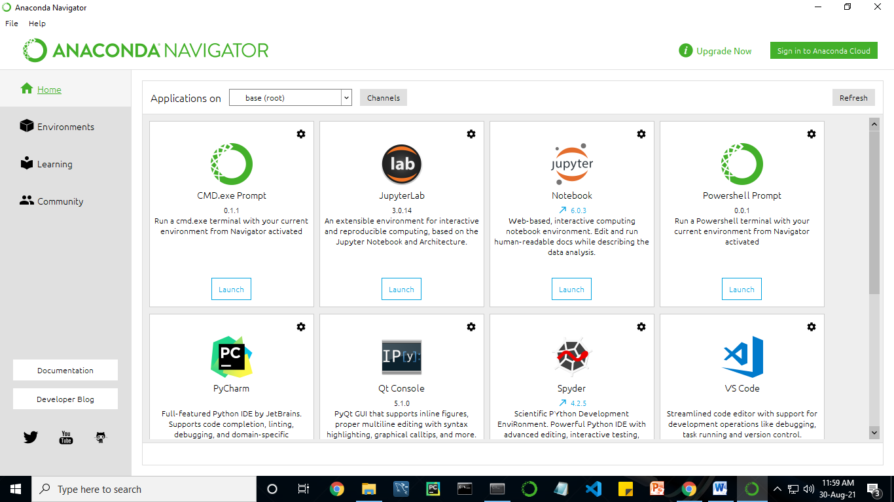

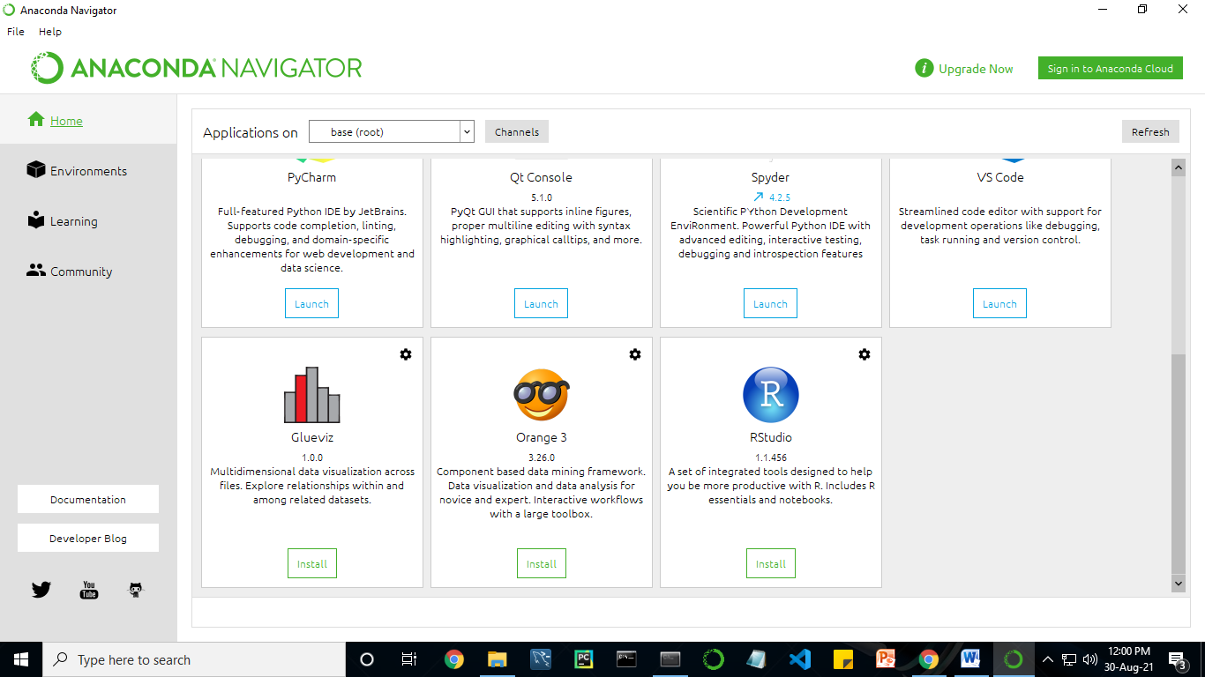

13.2 JUPYTER NOTEBOOK
This website acts as “meta” documentation for the Jupyter ecosystem. It has a collection of resources to navigate the tools and communities in this ecosystem, and to help you get started.
Project Jupyter is a project and community whose goal is to "develop open-source software, open-standards, and services for interactive computing across dozens of programming languages". It was spun off from IPython in 2014 by Fernando Perez.
Notebook documents are documents produced by the Jupyter Notebook App, which contain both computer code (e.g. python) and rich text elements (paragraph, equations, figures, links, etc…). Notebook documents are both human-readable documents containing the analysis description and the results (figures, tables, etc.) as well as executable documents which can be run to perform data analysis.

14. PYTHON
Introduction:
Python is an interpreted high-level general-purpose programming language. Its design philosophy emphasizes code readability with its use of significant indentation. Its language constructs as well as its object-oriented approach aim to help programmers write clear, logical code for small and large-scale projects.
Python is dynamically-typed and garbage-collected. It supports multiple programming paradigms, including structured (particularly, procedural), object-oriented and functional programming. It is often described as a "batteries included" language due to its comprehensive standard library.
Guido van Rossum began working on Python in the late 1980s, as a successor to the ABC programming language, and first released it in 1991 as Python 0.9.0. Python 2.0 was released in 2000 and introduced new features, such as list comprehensions and a garbage collection system using reference counting. Python 3.0 was released in 2008 and was a major revision of the language that is not completely backward-compatible. Python 2 was discontinued with version 2.7.18 in 2020.
Python consistently ranks as one of the most popular programming languages

Methods :
Methods on objects are functions attached to the object's class; the syntax instance.method(argument) is, for normal methods and functions, syntactic sugar for Class.method(instance, argument). Python methods have an explicit self parameter access instance data, in contrast to the implicit self (or this) in some other object-oriented programming languages (e.g., C++, Java, Objective-C, or Ruby). Apart from this Python also provides methods, sometimes called d-under methods due to their names beginning and ending with double-underscores, to extend the functionality of custom class to support native functions such as print, length, comparison, support for arithmetic operations, type conversion, and many more.

Typing :
Python uses duck typing and has typed objects but untyped variable names. Type constraints are not checked at compile time; rather, operations on an object may fail, signifying that the given object is not of a suitable type. Despite being dynamically-typed, Python is strongly-typed, forbidding operations that are not well-defined (for example, adding a number to a string) rather than silently attempting to make sense of them.
Python allows programmers to define their own types using classes, which are most often used for object-oriented programming. New instances of classes are constructed by calling the class (for example, SpamClass() or EggsClass()), and the classes are instances of the metaclass type (itself an instance of itself), allowing meta-programming and reflection.
Before version 3.0, Python had two kinds of classes: old-style and new-style. The syntax of both styles is the same, the difference being whether the class object is inherited from, directly or indirectly (all new-style classes inherit from object and are instances of type). In versions of Python 2 from Python 2.2 onwards, both kinds of classes can be used. Old-style classes were eliminated in Python 3.0.
The long-term plan is to support gradual typing and from Python 3.5, the syntax of the language allows specifying static types but they are not checked in the default implementation, CPython. An experimental optional static type checker named mypy supports compile-time type checking.

15. System Architecture

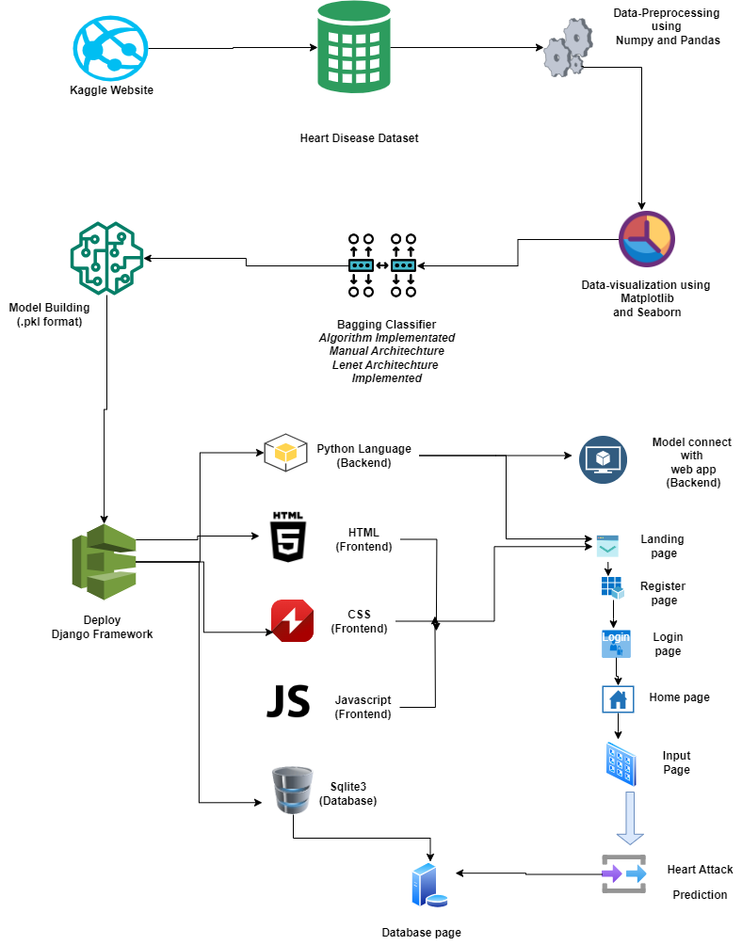

16. Work flow diagram

Source Data

Data Processing and Cleaning

Testing Dataset
Training Dataset

Best Model by Accuracy
Classification ML Algorithms

Predicting Heart – Brain co ordinated stress level

Workflow Diagram

17. Use Case Diagram

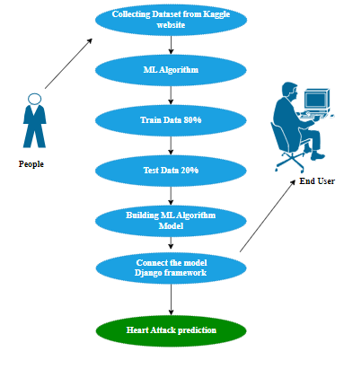
Use case diagrams are considered for high level requirement analysis of a system. So when the requirements of a system are analyzed the functionalities are captured in use cases. So, it can say that uses cases are nothing but the system functionalities written in an organized manner.

18. Class Diagram:

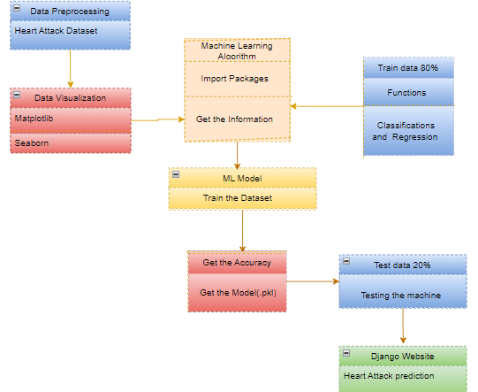
Class diagram is basically a graphical representation of the static view of the system and represents different aspects of the application. So a collection of class diagrams represent the whole system. The name of the class diagram should be meaningful to describe the aspect of the system. Each element and their relationships should be identified in advance Responsibility (attributes and methods) of each class should be clearly identified for each class minimum number of properties should be specified and because, unnecessary properties will make the diagram complicated. Use notes whenever required to describe some aspect of the diagram and at the end of the drawing it should be understandable to the developer/coder. Finally, before making the final version, the diagram should be drawn on plain paper and rework as many times as possible to make it correct.

19. Activity Diagram:

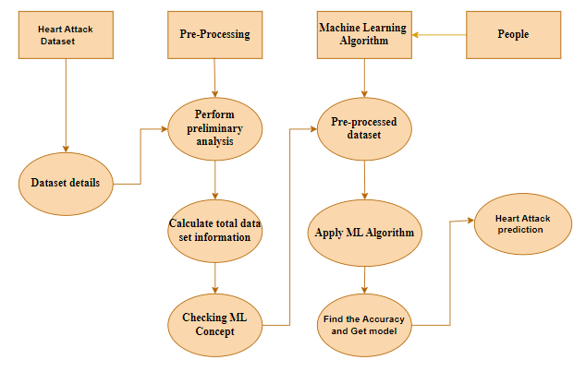
Activity is a particular operation of the system. Activity diagrams are not only used for visualizing dynamic nature of a system but they are also used to construct the executable system by using forward and reverse engineering techniques. The only missing thing in activity diagram is the message part. It does not show any message flow from one activity to another. Activity diagram is some time considered as the flow chart. Although the diagrams looks like a flow chart but it is not. It shows different flow like parallel, branched, concurrent and single.

20. Sequence Diagram:

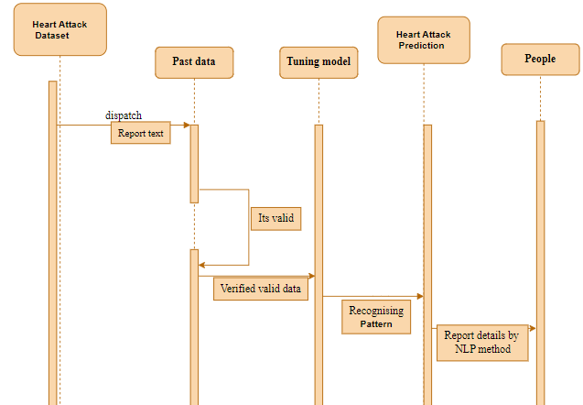
Sequence diagrams model the flow of logic within your system in a visual manner, enabling you both to document and validate your logic, and are commonly used for both analysis and design purposes. Sequence diagrams are the most popular UML artifact for dynamic modelling, which focuses on identifying the behaviour within your system. Other dynamic modelling techniques include activity diagramming, communication diagramming, timing diagramming, and interaction overview diagramming. Sequence diagrams, along with class diagrams and physical data models are in my opinion the most important design-level models for modern business application development.

21. Entity Relationship Diagram (ERD)

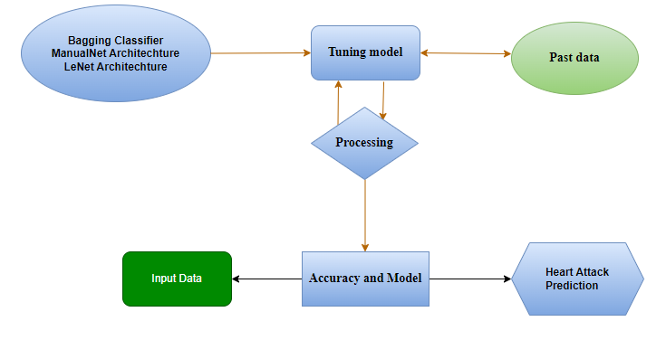
An entity relationship diagram (ERD), also known as an entity relationship model, is a graphical representation of an information system that depicts the relationships among people, objects, places, concepts or events within that system. An ERD is a data modeling technique that can help define business processes and be used as the foundation for a relational database. Entity relationship diagrams provide a visual starting point for database design that can also be used to help determine information system requirements throughout an organization. After a relational database is rolled out, an ERD can still serve as a referral point, should any debugging or business process re-engineering be needed later.

ARCHITECTURE OF CNN
CONVOLUTIONAL NEURAL NETWORK:
A Convolutional neural network (CNN) is one type of Artificial Neural Network. A Convolutional neural network (CNN) is a neural network that has one or more convolutional layers and are used mainly for image processing, classification, segmentation and also for other auto correlated data.

Models API:
There are three ways to create Keras models:
• The Sequential model, which is very straightforward (a simple list of layers), but is limited to single-input, single-output stacks of layers (as the name gives away).
• The Functional API, which is an easy-to-use, fully-featured API that supports arbitrary model architectures. For most people and most use cases, this is what you should be using. This is the Keras "industry strength" model.
• Model subclassing, where you implement everything from scratch on your own. Use this if you have complex, out-of-the-box research use cases.

Types of Keras Models
Models in keras are available in two types:
• Keras Sequential Model
• Keras Functional API

1. Sequential Model in Keras
It allows us to create models layer by layer in sequential order. But it does not allow us to create models that have multiple inputs or outputs.
It is best for simple stack of layers which have 1 input tensor and 1 output tensor.
This model is not suited when any of the layer in the stack has multiple inputs or outputs. Even if we want non-linear topology, it is not suited.

2. Functional API in Keras
It provides more flexibility to define a model and add layers in keras. Functional API allows us to create models that have multiple input or output.
It also allows us to share these layers. In other words. we can make graphs of layers using Keras functional API.
As functional API is a data structure, it is easy to save it as a single file that helps in recreating the exact model without having the original code. Also its easy to model the graph here and access its nodes as well.

Model Subclassing in Keras
Sequential model does not allow you much flexibility to create your models. Functional API also only has a little of customization available for you. But you may create your own fully-customizable models in Keras. This is done by subclassing the Model class and implementing a call method.
Input() is used to instantiate a Keras tensor.
A Keras tensor is a symbolic tensor-like object, which we augment with certain attributes that allow us to build a Keras model just by knowing the inputs and outputs of the model.
For instance, if a, b and c are Keras tensors, it becomes possible to do: model = Model(input=[a, b], output=c)

kernels:
Each convolutional layer contains a series of filters known as convolutional kernels. The filter is a matrix of integers that are used on a subset of the input pixel values, the same size as the kernel. Each pixel is multiplied by the corresponding value in the kernel, then the result is summed up for a single value for simplicity representing a grid cell, like a pixel, in the output channel/feature map. These are linear transformations, each convolution is a type of affine function.
In computer vision the input is often a 3 channel RGB image. For simplicity, if we take a greyscale image that has one channel (a two dimensional matrix) and a 3x3 convolutional kernel (a two dimensional matrix). The kernel strides over the input matrix of numbers moving horizontally column by column, sliding/scanning over the first rows in the matrix containing the images pixel values. Then the kernel strides down vertically to subsequent rows. Note, the filter may stride over one or several pixels at a time, this is detailed further below.
In other non-vision applications, a one dimensional convolution may slide vertically over an input matrix.
Padding:
To handle the edge pixels there are several approaches:
- Losing the edge pixels
- Padding with zero value pixels
- Reflection padding
Reflection padding is by far the best approach, where the number of pixels needed for the convolutional kernel to process the edge pixels are added onto the outside copying the pixels from the edge of the image. For a 3x3 kernel, one pixel needs to be added around the outside, for a 7x7 kernel then three pixels would be reflected around the outside. The pixels added around each side is the dimension, halved and rounded down.
Traditionally in many research papers, the edge pixels are just ignored, which loses a small proportion of the data and this gets increasing worse if there are many deep convolutional layers. For this reason, I could not find existing diagrams to easily convey some of the points here without being misleading and confusing stride 1 convolutions with stride 2 convolutions.
With padding, the output from a input of width w and height h would be width w and height h (the same as the input with a single input channel), assuming the kernel takes a stride of one pixel at a time.

Strides:
It is common to use a stride two convolution rather than a stride one convolution, where the convolutional kernel strides over 2 pixels at a time, for example our 3x3 kernel would start at position (1,1), then stride to (1,3), then to 1, 5) and so on, halving the size of the output channel/feature map, compared to the convolutional kernel taking strides of one.
With padding, the output from an input of width w, height h and depth 3 would be the ceiling of width w/2, height h/2 and depth 1, as the kernel outputs a single summed output from each stride.

Rectified Linear Unit (ReLU):
A Rectified Linear Unit is used as a non-linear activation function. A ReLU says if the value is less than zero, round it up to zero.

Normalisation:
Normalisation is the process of subtracting the mean and dividing by the standard deviation. It transforms the range of the data to be between -1 and 1 making the data use the same scale, sometimes called Min-Max scaling.
It is common to normalize the input features, standardising the data by removing the mean and scaling to unit variance. It is often important the input features are centred around zero and have variance in the same order. With some data, such as images the data is scaled so that it’s range is between 0 and 1, most simply dividing the pixel values by 255.

Batch normalisation:
Batch normalisation has the benefits of helping to make a network output more stable predictions, reduce overfitting through regularisation and speeds up training by an order of magnitude.
Batch normalisation is the process of carrying normalisation within the scope activation layer of the current batch, subtracting the mean of the batch’s activations and dividing by the standard deviation of the batches activations.
This is necessary as even after normalizing the input as some activations can be higher, which can cause the subsequent layers to act abnormally and makes the network less stable.
Batch normalization applies a transformation that maintains the mean output close to 0 and the output standard deviation close to 1.
Importantly, batch normalization works differently during training and during inference.
During training (i.e. when using fit() or when calling the layer/model with the argument training=True), the layer normalizes its output using the mean and standard deviation of the current batch of inputs. That is to say, for each channel being normalized, the layer returns gamma * (batch - mean(batch)) / sqrt(var(batch) + epsilon) + beta, where:
- epsilon is small constant (configurable as part of the constructor arguments)
- gamma is a learned scaling factor (initialized as 1), which can be disabled by passing scale=False to the constructor.
- beta is a learned offset factor (initialized as 0), which can be disabled by passing center=False to the constructor.

During inference (i.e. when using evaluate() or predict() or when calling the layer/model with the argument training=False (which is the default), the layer normalizes its output using a moving average of the mean and standard deviation of the batches it has seen during training. That is to say, it returns gamma * (batch - self.moving_mean) / sqrt(self.moving_var + epsilon) + beta.
self.moving_mean and self.moving_var are non-trainable variables that are updated each time the layer in called in training mode, as such:
- moving_mean = moving_mean * momentum + mean(batch) * (1 - momentum)
- moving_var = moving_var * momentum + var(batch) * (1 - momentum)
As such, the layer will only normalize its inputs during inference after having been trained on data that has similar statistics as the inference data.
Arguments
- axis: Integer, the axis that should be normalized (typically the features axis). For instance, after a Conv2D layer with data_format="channels_first", set axis=1 in BatchNormalization.
- momentum: Momentum for the moving average.
- epsilon: Small float added to variance to avoid dividing by zero.
- center: If True, add offset of beta to normalized tensor. If False, beta is ignored.
- scale: If True, multiply by gamma. If False, gamma is not used. When the next layer is linear (also e.g. nn.relu), this can be disabled since the scaling will be done by the next layer.
- beta_initializer: Initializer for the beta weight.
- gamma_initializer: Initializer for the gamma weight.
- moving_mean_initializer: Initializer for the moving mean.
- moving_variance_initializer: Initializer for the moving variance.
- beta_regularizer: Optional regularizer for the beta weight.
- gamma_regularizer: Optional regularizer for the gamma weight.
- beta_constraint: Optional constraint for the beta weight.
- gamma_constraint: Optional constraint for the gamma weight.
Call arguments
- inputs: Input tensor (of any rank).
- training: Python boolean indicating whether the layer should behave in training mode or in inference mode.

22. Module description:
Data Pre-processing
Validation techniques in machine learning are used to get the error rate of the Machine Learning (ML) model, which can be considered as close to the true error rate of the dataset. If the data volume is large enough to be representative of the population, you may not need the validation techniques. However, in real-world scenarios, to work with samples of data that may not be a true representative of the population of given dataset. To finding the missing value, duplicate value and description of data type whether it is float variable or integer. The sample of data used to provide an unbiased evaluation of a model fit on the training dataset while tuning model hyper parameters.
The evaluation becomes more biased as skill on the validation dataset is incorporated into the model configuration. The validation set is used to evaluate a given model, but this is for frequent evaluation. It as machine learning engineers use this data to fine-tune the model hyper parameters. Data collection, data analysis, and the process of addressing data content, quality, and structure can add up to a time-consuming to-do list. During the process of data identification, it helps to understand your data and its properties; this knowledge will help you choose which algorithm to use to build your model.
A number of different data cleaning tasks using Python’s Pandas library and specifically, it focus on probably the biggest data cleaning task, missing values and it able to more quickly clean data. It wants to spend less time cleaning data, and more time exploring and modeling.
Some of these sources are just simple random mistakes. Other times, there can be a deeper reason why data is missing. It’s important to understand these different types of missing data from a statistics point of view. The type of missing data will influence how to deal with filling in the missing values and to detect missing values, and do some basic imputation and detailed statistical approach for dealing with missing data. Before, joint into code, it’s important to understand the sources of missing data. Here are some typical reasons why data is missing:
- User forgot to fill in a field.
- Data was lost while transferring manually from a legacy database.
- There was a programming error.
- Users chose not to fill out a field tied to their beliefs about how the results would be used or interpreted.

Variable identification with Uni-variate, Bi-variate and Multi-variate analysis:
- import libraries for access and functional purpose and read the given dataset
- General Properties of Analyzing the given dataset
- Display the given dataset in the form of data frame
- show columns
- shape of the data frame
- To describe the data frame
- Checking data type and information about dataset
- Checking for duplicate data
- Checking Missing values of data frame
- Checking unique values of data frame
- Checking count values of data frame
- Rename and drop the given data frame
- To specify the type of values
- To create extra columns

Data Validation/ Cleaning/Preparing Process
Importing the library packages with loading given dataset. To analyzing the variable identification by data shape, data type and evaluating the missing values, duplicate values. A validation dataset is a sample of data held back from training your model that is used to give an estimate of model skill while tuning models and procedures that you can use to make the best use of validation and test datasets when evaluating your models. Data cleaning / preparing by rename the given dataset and drop the column etc. to analyze the uni-variate, bi-variate and multi-variate process. The steps and techniques for data cleaning will vary from dataset to dataset. The primary goal of data cleaning is to detect and remove errors and anomalies to increase the value of data in analytics and decision making.

MODULE DIAGRAM
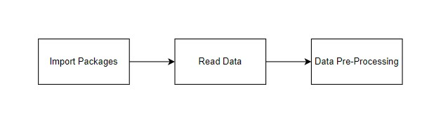

GIVEN INPUT EXPECTED OUTPUT
input : data
output : removing noisy data
Exploration data analysis of visualization
Data visualization is an important skill in applied statistics and machine learning. Statistics does indeed focus on quantitative descriptions and estimations of data. Data visualization provides an important suite of tools for gaining a qualitative understanding. This can be helpful when exploring and getting to know a dataset and can help with identifying patterns, corrupt data, outliers, and much more. With a little domain knowledge, data visualizations can be used to express and demonstrate key relationships in plots and charts that are more visceral and stakeholders than measures of association or significance. Data visualization and exploratory data analysis are whole fields themselves and it will recommend a deeper dive into some the books mentioned at the end.
Sometimes data does not make sense until it can look at in a visual form, such as with charts and plots. Being able to quickly visualize of data samples and others is an important skill both in applied statistics and in applied machine learning. It will discover the many types of plots that you will need to know when visualizing data in Python and how to use them to better understand your own data.
- How to chart time series data with line plots and categorical quantities with bar charts.
- How to summarize data distributions with histograms and box plots.

Pre-processing refers to the transformations applied to our data before feeding it to the algorithm. Data Preprocessing is a technique that is used to convert the raw data into a clean data set. In other words, whenever the data is gathered from different sources it is collected in raw format which is not feasible for the analysis. To achieving better results from the applied model in Machine Learning method of the data has to be in a proper manner. Some specified Machine Learning model needs information in a specified format, for example, Random Forest algorithm does not support null values. Therefore, to execute random forest algorithm null values have to be managed from the original raw data set. And another aspect is that data set should be formatted in such a way that more than one Machine Learning and Deep Learning algorithms are executed in given dataset.

MODULE DIAGRAM
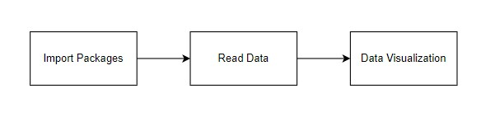
GIVEN INPUT EXPECTED OUTPUT
input : data
output : visualized data
Comparing Algorithm with prediction in the form of best accuracy result
It is important to compare the performance of multiple different machine learning algorithms consistently and it will discover to create a test harness to compare multiple different machine learning algorithms in Python with scikit-learn. It can use this test harness as a template on your own machine learning problems and add more and different algorithms to compare. Each model will have different performance characteristics. Using resampling methods like cross validation, you can get an estimate for how accurate each model may be on unseen data. It needs to be able to use these estimates to choose one or two best models from the suite of models that you have created. When have a new dataset, it is a good idea to visualize the data using different techniques in order to look at the data from different perspectives. The same idea applies to model selection. You should use a number of different ways of looking at the estimated accuracy of your machine learning algorithms in order to choose the one or two to finalize. A way to do this is to use different visualization methods to show the average accuracy, variance and other properties of the distribution of model accuracies.
In the next section you will discover exactly how you can do that in Python with scikit-learn. The key to a fair comparison of machine learning algorithms is ensuring that each algorithm is evaluated in the same way on the same data and it can achieve this by forcing each algorithm to be evaluated on a consistent test harness.
In the example below 3 different algorithms are compared:
- Data Preprocessing
- Data Visualization
- MLP Classifier
- Bagging Classifier

The K-fold cross validation procedure is used to evaluate each algorithm, importantly configured with the same random seed to ensure that the same splits to the training data are performed and that each algorithm is evaluated in precisely the same way. Before that comparing algorithm, Building a Machine Learning Model using install Scikit-Learn libraries. In this library package have to done preprocessing, linear model with logistic regression method, cross validating by KFold method, ensemble with random forest method and tree with decision tree classifier. Additionally, splitting the train set and test set. To predicting the result by comparing accuracy.

Prediction result by accuracy:
Logistic regression algorithm also uses a linear equation with independent predictors to predict a value. The predicted value can be anywhere between negative infinity to positive infinity. It need the output of the algorithm to be classified variable data. Higher accuracy predicting result is logistic regression model by comparing the best accuracy.

False Positives (FP): A person who will pay predicted as defaulter. When actual class is no and predicted class is yes. E.g. if actual class says this passenger did not survive but predicted class tells you that this passenger will survive.
False Negatives (FN): A person who default predicted as payer. When actual class is yes but predicted class in no. E.g. if actual class value indicates that this passenger survived and predicted class tells you that passenger will die.
True Positives (TP): A person who will not pay predicted as defaulter. These are the correctly predicted positive values which means that the value of actual class is yes and the value of predicted class is also yes. E.g. if actual class value indicates that this passenger survived and predicted class tells you the same thing.
True Negatives (TN): A person who default predicted as payer. These are the correctly predicted negative values which means that the value of actual class is no and value of predicted class is also no. E.g. if actual class says this passenger did not survive and predicted class tells you the same thing.

True Positive Rate(TPR) = TP / (TP + FN)
False Positive rate(FPR) = FP / (FP + TN)

Accuracy: The Proportion of the total number of predictions that is correct otherwise overall how often the model predicts correctly defaulters and non-defaulters.
Accuracy calculation:
Accuracy = (TP + TN) / (TP + TN + FP + FN)
Accuracy is the most intuitive performance measure and it is simply a ratio of correctly predicted observation to the total observations. One may think that, if we have high accuracy then our model is best. Yes, accuracy is a great measure but only when you have symmetric datasets where values of false positive and false negatives are almost same.
Precision: The proportion of positive predictions that are actually correct.
Precision = TP / (TP + FP)
Precision is the ratio of correctly predicted positive observations to the total predicted positive observations. The question that this metric answer is of all passengers that labelled as survived, how many actually survived? High precision relates to the low false positive rate. We have got 0.788 precision which is pretty good.
Recall: The proportion of positive observed values correctly predicted. (The proportion of actual defaulters that the model will correctly predict)
Recall = TP / (TP + FN)
Recall(Sensitivity) - Recall is the ratio of correctly predicted positive observations to the all observations in actual class - yes.
F1 Score is the weighted average of Precision and Recall. Therefore, this score takes both false positives and false negatives into account. Intuitively it is not as easy to understand as accuracy, but F1 is usually more useful than accuracy, especially if you have an uneven class distribution. Accuracy works best if false positives and false negatives have similar cost. If the cost of false positives and false negatives are very different, it’s better to look at both Precision and Recall.

General Formula:
F- Measure = 2TP / (2TP + FP + FN)
F1-Score Formula:
F1 Score = 2*(Recall * Precision) / (Recall + Precision)

ALGORITHM AND TECHNIQUES:
Algorithm Explanation:
In machine learning and statistics, classification is a supervised learning approach in which the computer program learns from the data input given to it and then uses this learning to classify new observation. This data set may simply be bi-class (like identifying whether the person is male or female or that the mail is spam or non-spam) or it may be multi-class too. Some examples of classification problems are: speech recognition, handwriting recognition, bio metric identification, document classification etc. In Supervised Learning, algorithms learn from labelled data. After understanding the data, the algorithm determines which label should be given to new data based on pattern and associating the patterns to the unlabelled new data.

Used Python Packages:
sklearn:
  - In python, sklearn is a machine learning package which include a lot of ML algorithms.
  - Here, we are using some of its modules like train_test_split, DecisionTreeClassifier or Logistic Regression and accuracy_score.
NumPy:
  - It is a numeric python module which provides fast maths functions for calculations.
  - It is used to read data in numpy arrays and for manipulation purpose.
Pandas:
  - Used to read and write different files.
  - Data manipulation can be done easily with data frames.

Matplotlib:
  - Data visualization is a useful way to help with identify the patterns from given dataset.
  - Data manipulation can be done easily with data frames.

Bagging Classifier:
Bagging, or bootstrap aggregation, is the ensemble getting-to-know method generally used to lessen variance within a loud dataset. In Bagging, a random pattern of statistics in this study set is selected with replacement, meaning that the character statistics factors may be chosen more soon as possible. After numerous facts samples are generated, those susceptible fashions are trained independently. For example, the common or Majority of these predictions yield a correct estimate depending on the sort of task- regression or type. As a note, the random woodland set of rules is considered an extension of the bagging approach, using both bagging and function randomness to create an uncorrelated wooded area of selection trees.
The Bagging is an assembling approach that tries to resolve overfitting for class or the regression problems. Bagging pursuits to improve the accuracy and overall performance of gadget mastering algorithms. It does this by taking random subsets of an original dataset, with substitute, and fits either a classifier (for classification) or regressor (for regression) to each subset. Bagging is also known as Bootstrap aggregating. It is an ensemble learning approach that enhances the overall performance and accuracy of the gadget for learning algorithms. It is miles used to address bias-variance alternate-off increases and decreases the variance of a prediction version. The Bagging avoids overfitting of data and is used for each regression and classification of the class, in particular for the decision tree algorithms.
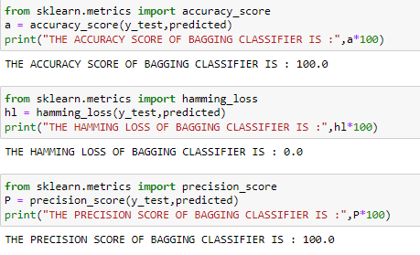
MODULE DIAGRAM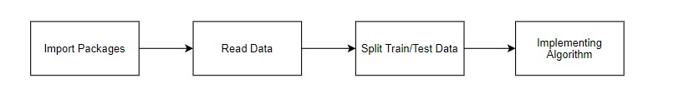
GIVEN INPUT EXPECTED OUTPUT
input : data
output : getting accuracy

Manual Architecture:
The manual architecture of the project outlines the systematic and organized approach for developing and managing the project's various components. It begins with a detailed analysis of the requirements and objectives, defining the scope and goals of the project. The architecture is designed to ensure that all components are well-integrated, scalable, and maintainable.
At its core, the manual architecture includes several key elements: the overall system design, the software and hardware infrastructure, and the interaction between different modules. The system design is laid out with a focus on modularity, allowing each component to function independently while communicating effectively with others. This includes defining the data flow, control flow, and interaction between different layers of the system.

LeNET:
LeNet is a small network, it contains the basic modules of deep learning: convolutional layer, pooling layer, and full link layer. It is the basis of other deep learning models. Here we analyze LeNet5 in depth. At the same time, through example analysis, deepen the understanding of the convolutional layer and pooling layer. Let’s understand the architecture of Lenet-5. The network has 5 layers with learnable parameters and hence named Lenet-5. It has three sets of convolution layers with a combination of average pooling. After the convolution and average pooling layers, we have two fully connected layers. At last, a Softmax classifier which classifies the images into respective class.
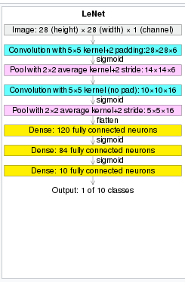

Convolutional layers:
Convolutional layers are the layers where filters are applied to the original image, or to other feature maps in a deep CNN. This is where most of the user-specified parameters are in the network. The most important parameters are the number of kernels and the size of the kernels.
Pooling layers:
Pooling layers are similar to convolutional layers, but they perform a specific function such as max pooling, which takes the maximum value in a certain filter region, or average pooling, which takes the average value in a filter region. These are typically used to reduce the dimensionality of the network.
Dense or Fully connected layers:
Fully connected layers are placed before the classification output of a CNN and are used to flatten the results before classification. This is similar to the output layer of an MLP.

23. Deployment:

Django (Web FrameWork) :
Django is an extremely popular and fully featured server-side web framework, written in Python. This module shows you why Django is one of the most popular web server frameworks, how to set up a development environment, and how to start using it to create your own web applications. In this first Django article we answer the question "What is Django?" and give you an overview of what makes this web framework special. We'll outline the main features, including some advanced functionality that we won't have time to cover in detail in this module. We'll also show you some of the main building blocks of a Django application, to give you an idea of what it can do before you set it up and start playing. Now that you know what Django is for, we'll show you how to set up and test a Django development environment on Windows, Linux (Ubuntu), and macOS — whatever common operating system you are using, this article should give you what you need to be able to start developing Django apps. Django is a high-level Python web framework that enables rapid development of secure and maintainable websites. Built by experienced developers, Django takes care of much of the hassle of web development, so you can focus on writing your app without needing to reinvent the wheel.
Complete
Django follows the "Batteries included" philosophy and provides almost everything developers might want to do "out of the box". Because everything you need is part of the one "product", it all works seamlessly together, follows consistent design principles, and has extensive and up-to-date documentation.

Versatile:
Django can be (and has been) used to build almost any type of website — from content management systems and wikis, through to social networks and news sites. It can work with any client-side framework, and can deliver content in almost any format (including HTML, RSS feeds, JSON, XML, etc). The site you are currently reading is built with Django!

Internally, while it provides choices for almost any functionality you might want (e.g. several popular databases, templating engines, etc.), it can also be extended to use other components if needed.

Secure:
• Django helps developers avoid many common security mistakes by providing a framework that has been engineered to "do the right things" to protect the website automatically. For example, Django provides a secure way to manage user accounts and passwords, avoiding common mistakes like putting session information in cookies where it is vulnerable (instead cookies just contain a key, and the actual data is stored in the database) or directly storing passwords rather than a password hash.

A password hash is a fixed-length value created by sending the password through a cryptographic hash function. Django can check if an entered password is correct by running it through the hash function and comparing the output to the stored hash value. However due to the "one-way" nature of the function, even if a stored hash value is compromised it is hard for an attacker to work out the original password.

Django enables protection against many vulnerabilities by default, including SQL injection, cross-site scripting, cross-site request forgery and clickjacking (see Website security for more details of such attacks).

Scalable:
Django uses a component-based “shared-nothing” architecture (each part of the architecture is independent of the others, and can hence be replaced or changed if needed). Having a clear separation between the different parts means that it can scale for increased traffic by adding hardware at any level: caching servers, database servers, or application servers. Some of the busiest sites have successfully scaled Django to meet their demands (e.g. Instagram and Disqus, to name just two).

Maintainable:
Django code is written using design principles and patterns that encourage the creation of maintainable and reusable code. In particular, it makes use of the Don't Repeat Yourself (DRY) principle so there is no unnecessary duplication, reducing the amount of code. Django also promotes the grouping of related functionality into reusable "applications" and, at a lower level, groups related code into modules (along the lines of the Model View Controller (MVC) pattern).

Portable:
Django is written in Python, which runs on many platforms. That means that you are not tied to any particular server platform, and can run your applications on many flavours of Linux, Windows, and Mac OS X. Furthermore, Django is well-supported by many web hosting providers, who often provide specific infrastructure and documentation for hosting Django sites.

MODULES:
# MLP CLASSIFIER ALGORITHM
import pandas as pd
import numpy as np
import matplotlib.pyplot as plt
import seaborn as sns

import warnings
warnings.filterwarnings('ignore')
df = pd.read_csv('NeuroCardio.csv')
del df["BP value"]
df.head()
df=df.dropna()
df.columns
from sklearn.preprocessing import LabelEncoder
le = LabelEncoder()

var = ['Gender','Stress level']

for i in var:
df[i] = le.fit_transform(df[i]).astype(int)
df.head()
x1 = df.drop(labels='Stress level', axis=1)
y1 = df.loc[:,'Stress level']
import imblearn
from imblearn.over_sampling import RandomOverSampler
from collections import Counter

ros =RandomOverSampler(random_state=42)
x,y=ros.fit_resample(x1,y1)
print("OUR DATASET COUNT : ", Counter(y1))
print("OVER SAMPLING DATA COUNT : ", Counter(y))
from sklearn.model_selection import train_test_split
x_train, x_test, y_train, y_test = train_test_split(x, y, test_size=0.20, random_state=42, stratify=y)
print("NUMBER OF TRAIN DATASET : ", len(x_train))
print("NUMBER OF TEST DATASET : ", len(x_test))
print("TOTAL NUMBER OF DATASET : ", len(x_train)+len(x_test))
print("NUMBER OF TRAIN DATASET : ", len(y_train))
print("NUMBER OF TEST DATASET : ", len(y_test))
print("TOTAL NUMBER OF DATASET : ", len(y_train)+len(y_test))
from sklearn.neural_network import MLPClassifier
MLP = MLPClassifier()
MLP.fit(x_train,y_train)
predicted = MLP.predict(x_test)
from sklearn.metrics import accuracy_score
accuracy = accuracy_score(y_test, predicted)
print('ACCURACY OF THIS MODEL :\n\n', accuracy*100)
from sklearn.metrics import classification_report
cr = classification_report(y_test,predicted)
print('THE CLASSIFICATION REPORT OF MLP CLASSIFIER:\n\n',cr)
from sklearn.metrics import confusion_matrix
cm = confusion_matrix(y_test,predicted)
print('THE CONFUSION MATRIX SCORE OF MLP CLASSIFIER:\n\n\n',cm)
from sklearn.model_selection import cross_val_score
accuracy = cross_val_score(MLP, x, y, scoring='accuracy')
print('THE CROSS VALIDATION TEST RESULT OF ACCURACY :\n\n\n', accuracy*100)
from sklearn.metrics import accuracy_score
a = accuracy_score(y_test,predicted)
print("THE ACCURACY SCORE OF MLP CLASSIFIER IS :",a*100)
from sklearn.metrics import hamming_loss
hl = hamming_loss(y_test,predicted)
print("THE HAMMING LOSS OF MLP CLASSIFIER IS :",hl*100)
def plot_confusion_matrix(cm, title='THE CONFUSION MATRIX SCORE OF MLP CLASSIFIER\n\n', cmap=plt.cm.cool):
plt.imshow(cm, interpolation='nearest', cmap=cmap)
plt.title(title)
plt.colorbar()

cm1=confusion_matrix(y_test, predicted)
print('THE CONFUSION MATRIX SCORE OF MLP CLASSIFIER:\n\n')
print(cm)
plot_confusion_matrix(cm)
import matplotlib.pyplot as plt
df2 = pd.DataFrame()
df2["y_test"] = y_test
df2["predicted"] = predicted
df2.reset_index(inplace=True)
plt.figure(figsize=(20, 5))
plt.plot(df2["predicted"][:100], marker='x', linestyle='dashed', color='red')
plt.plot(df2["y_test"][:100], marker='o', linestyle='dashed', color='green')
plt.show()

# BAGGING CLASSIFIER ALGORITHM
import pandas as pd
import numpy as np
import matplotlib.pyplot as plt
import seaborn as sns

import warnings
warnings.filterwarnings('ignore')
df = pd.read_csv('NeuroCardio.csv')
del df["BP value"]
df.head()
df=df.dropna()
df.columns
from sklearn.preprocessing import LabelEncoder
le = LabelEncoder()

var = ['Gender','Stress level']

for i in var:
df[i] = le.fit_transform(df[i]).astype(int)
df.head()
x1 = df.drop(labels='Stress level', axis=1)
y1 = df.loc[:,'Stress level']
import imblearn
from imblearn.over_sampling import RandomOverSampler
from collections import Counter

ros =RandomOverSampler(random_state=42)
x,y=ros.fit_resample(x1,y1)
print("OUR DATASET COUNT : ", Counter(y1))
print("OVER SAMPLING DATA COUNT : ", Counter(y))
from sklearn.model_selection import train_test_split
x_train, x_test, y_train, y_test = train_test_split(x, y, test_size=0.20, random_state=42, stratify=y)
print("NUMBER OF TRAIN DATASET : ", len(x_train))
print("NUMBER OF TEST DATASET : ", len(x_test))
print("TOTAL NUMBER OF DATASET : ", len(x_train)+len(x_test))
print("NUMBER OF TRAIN DATASET : ", len(y_train))
print("NUMBER OF TEST DATASET : ", len(y_test))
print("TOTAL NUMBER OF DATASET : ", len(y_train)+len(y_test))
from sklearn.ensemble import BaggingClassifier
BAG = BaggingClassifier()
BAG.fit(x_train,y_train)
predicted = BAG.predict(x_test)
from sklearn.metrics import classification_report
cr = classification_report(y_test,predicted)
print('THE CLASSIFICATION REPORT OF BAGGING CLASSIFIER:\n\n',cr)
from sklearn.metrics import confusion_matrix
cm = confusion_matrix(y_test,predicted)
print('THE CONFUSION MATRIX SCORE OF BAGGING CLASSIFIER:\n\n\n',cm)
from sklearn.model_selection import cross_val_score
accuracy = cross_val_score(BAG, x, y, scoring='accuracy')
print('THE CROSS VALIDATION TEST RESULT OF ACCURACY :\n\n\n', accuracy*100)
from sklearn.metrics import accuracy_score
a = accuracy_score(y_test,predicted)
print("THE ACCURACY SCORE OF BAGGING CLASSIFIER IS :",a*100)
from sklearn.metrics import hamming_loss
hl = hamming_loss(y_test,predicted)
print("THE HAMMING LOSS OF BAGGING CLASSIFIER IS :",hl*100)
def plot_confusion_matrix(cm, title='THE CONFUSION MATRIX SCORE OF BAGGING CLASSIFIER\n\n', cmap=plt.cm.cool):
plt.imshow(cm, interpolation='nearest', cmap=cmap)
plt.title(title)
plt.colorbar()

cm1=confusion_matrix(y_test, predicted)
print('THE CONFUSION MATRIX SCORE OF BAGGING CLASSIFIER:\n\n')
print(cm)
plot_confusion_matrix(cm)
import matplotlib.pyplot as plt
df2 = pd.DataFrame()
df2["y_test"] = y_test
df2["predicted"] = predicted
df2.reset_index(inplace=True)
plt.figure(figsize=(20, 5))
plt.plot(df2["predicted"][:100], marker='x', linestyle='dashed', color='red')
plt.plot(df2["y_test"][:100], marker='o', linestyle='dashed', color='green')
plt.show()
import joblib
joblib.dump(BAG,'NeuroCardio.pkl')

CODE:
from django.shortcuts import render, redirect
from django.urls import reverse_lazy
from django.contrib.auth.views import LoginView, PasswordResetView, PasswordChangeView
from django.contrib import messages
from django.contrib.messages.views import SuccessMessageMixin
from django.views import View
from django.contrib.auth.decorators import login_required
from django.contrib.auth import logout as auth_logout
import numpy as np
import joblib
from .forms import RegisterForm, LoginForm, UpdateUserForm, UpdateProfileForm
from .models import StressData
from .forms import StressDataForm

def home(request):
return render(request, 'users/home.html')

@login_required(login_url='users-register')

def index(request):
return render(request, 'app/index.html')

class RegisterView(View):
form_class = RegisterForm
initial = {'key': 'value'}
template_name = 'users/register.html'

def dispatch(self, request, *args, **kwargs):
# will redirect to the home page if a user tries to access the register page while logged in
if request.user.is_authenticated:
return redirect(to='/')

# else process dispatch as it otherwise normally would
return super(RegisterView, self).dispatch(request, *args, **kwargs)

def get(self, request, *args, **kwargs):
form = self.form_class(initial=self.initial)
return render(request, self.template_name, {'form': form})

def post(self, request, *args, **kwargs):
form = self.form_class(request.POST)

if form.is_valid():
form.save()

username = form.cleaned_data.get('username')
messages.success(request, f'Account created for {username}')

return redirect(to='login')

return render(request, self.template_name, {'form': form})

# Class based view that extends from the built in login view to add a remember me functionality

class CustomLoginView(LoginView):
form_class = LoginForm

def form_valid(self, form):
remember_me = form.cleaned_data.get('remember_me')

if not remember_me:
# set session expiry to 0 seconds. So it will automatically close the session after the browser is closed.
self.request.session.set_expiry(0)

# Set session as modified to force data updates/cookie to be saved.
self.request.session.modified = True

# else browser session will be as long as the session cookie time "SESSION_COOKIE_AGE" defined in settings.py
return super(CustomLoginView, self).form_valid(form)

class ResetPasswordView(SuccessMessageMixin, PasswordResetView):
template_name = 'users/password_reset.html'
email_template_name = 'users/password_reset_email.html'
subject_template_name = 'users/password_reset_subject'
success_message = "We've emailed you instructions for setting your password, " \
"if an account exists with the email you entered. You should receive them shortly." \
" If you don't receive an email, " \
"please make sure you've entered the address you registered with, and check your spam folder."
success_url = reverse_lazy('users-home')

class ChangePasswordView(SuccessMessageMixin, PasswordChangeView):
template_name = 'users/change_password.html'
success_message = "Successfully Changed Your Password"
success_url = reverse_lazy('users-home')

@login_required
def profile(request):
if request.method == 'POST':
user_form = UpdateUserForm(request.POST, instance=request.user)
profile_form = UpdateProfileForm(request.POST, request.FILES, instance=request.user.profile)

if user_form.is_valid() and profile_form.is_valid():
user_form.save()
profile_form.save()
messages.success(request, 'Your profile is updated successfully')
return redirect(to='users-profile')
else:
user_form = UpdateUserForm(instance=request.user)
profile_form = UpdateProfileForm(instance=request.user.profile)

return render(request, 'users/profile.html', {'user_form': user_form, 'profile_form': profile_form})

Model = joblib.load('users/NeuroCardio.pkl')

import numpy as np
from django.shortcuts import render
from .forms import StressDataForm
from .models import StressData

def Deploy_8(request):
if request.method == 'POST':
form = StressDataForm(request.POST)

if form.is_valid():

Gender = form.cleaned_data['Gender']
Age = form.cleaned_data['Age']
Heart_rate_BPM = form.cleaned_data['Heart_rate_BPM']
Heart_rate_variability = form.cleaned_data['Heart_rate_variability']
Respiratory_rate = form.cleaned_data['Respiratory_rate']
Mental_Fatigue_level = form.cleaned_data['Mental_Fatigue_level']
Reaction_time_delay = form.cleaned_data['Reaction_time_delay']
Adrenaline = form.cleaned_data['Adrenaline']
Cortisol_level = form.cleaned_data['Cortisol_level']

# Feature array (order MUST match training)
features = np.array([[
Gender,
Age,
Heart_rate_BPM,
Heart_rate_variability,
Respiratory_rate,
Mental_Fatigue_level,
Reaction_time_delay,
Adrenaline,
Cortisol_level
]])

prediction = Model.predict(features)[0]

stress_map = {
0: 'Low',
1: 'Moderate',
2: 'High',
3: 'Very High'
}

result = stress_map.get(prediction, 'Unknown')
print("Predicted Stress Level:", result)

# Save to DB
instance = form.save(commit=False)
instance.Stress_level = result
instance.save()

return render(request, 'app/output.html', {'predict': result})

else:
print(form.errors)
return render(request, 'app/deploy_8.html', {'form': form})

else:
form = StressDataForm()

return render(request, 'app/deploy_8.html', {'form': form})

def Database(request):
data = StressData.objects.all().order_by('-created_at')
return render(request, 'app/database.html', {'data': data})

def logout_view(request):
auth_logout(request)
return redirect('/')
OUTPUT SCREENSHOTS:
(1)Landing page:

(2)Register page:
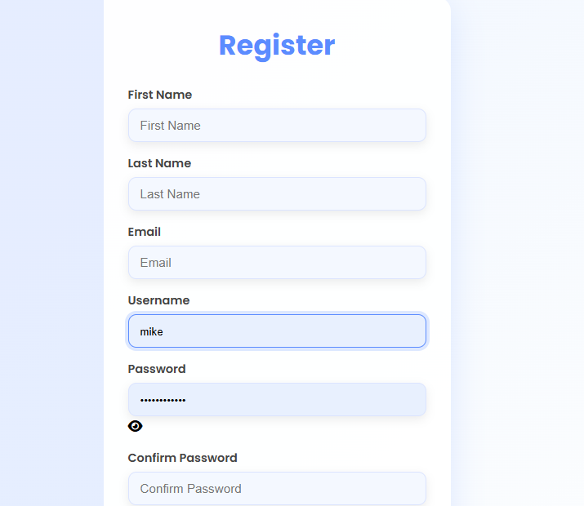
(3)Login page:
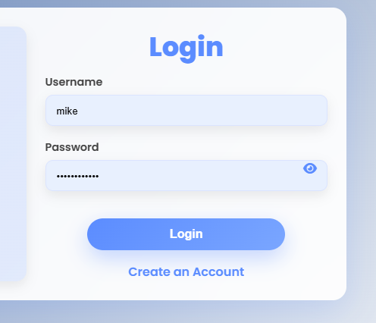
(4) Home page:

(5) Database page:
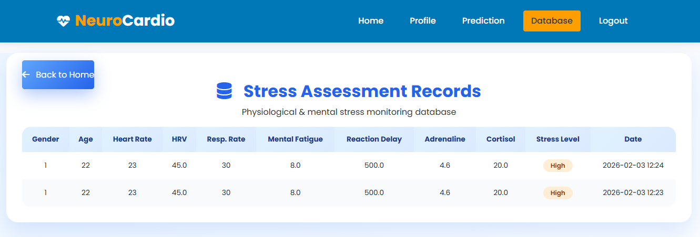
(6) Input page:
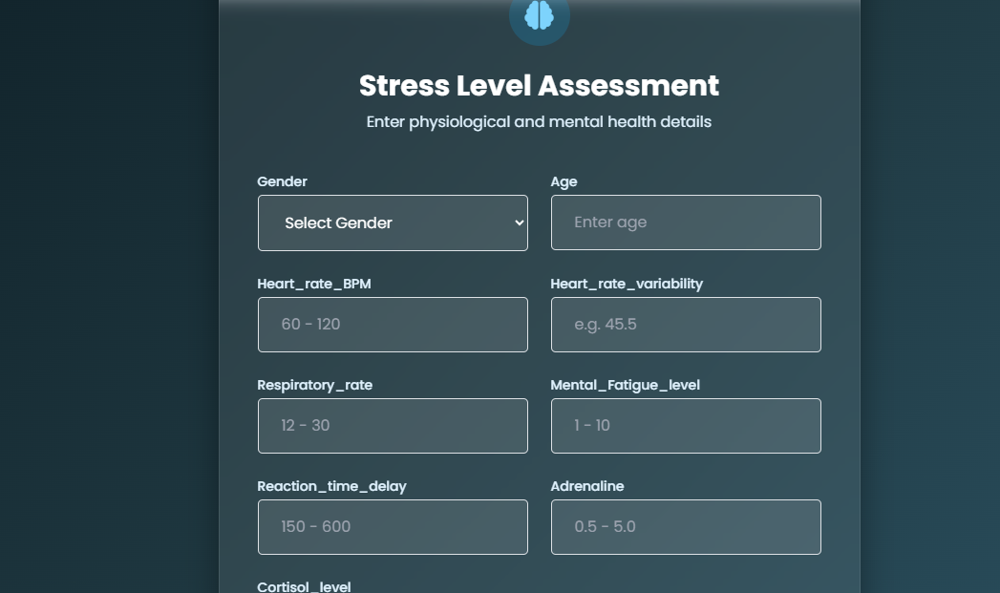
(7) Output page:
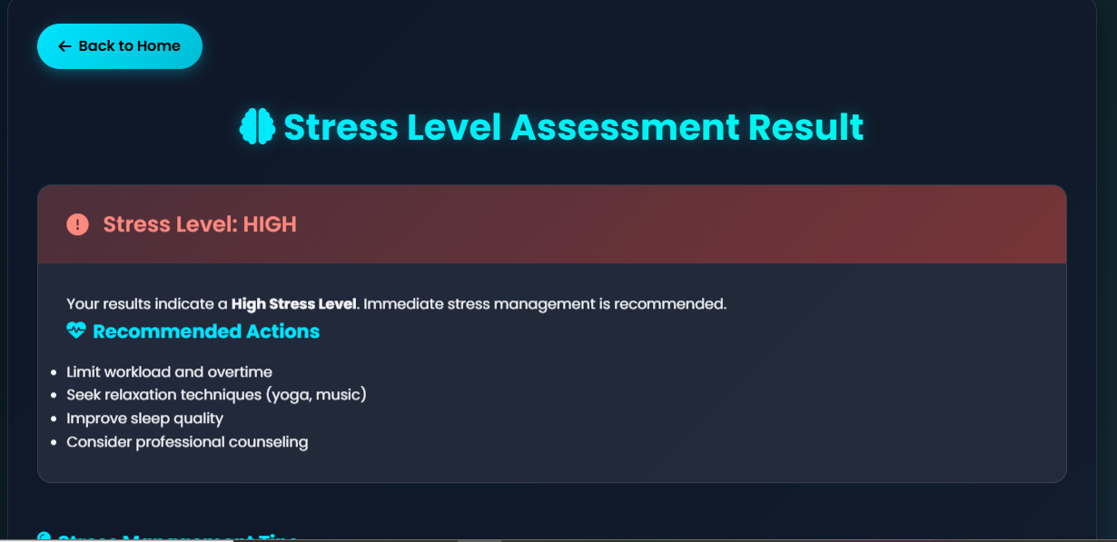

27. Conclusion
The analytical process started from data cleaning and processing, missing value, exploratory analysis and finally model building and evaluation. The best accuracy on public test set is higher accuracy score will be find out. This application can help to find the Prediction of stress level using Neurocardio symptoms.

28. Future Work
- Heart Attack prediction to connect with cloud.
- To optimize the work to implement in Artificial Intelligence environment.

